**DESIGN METHODOLOGY FOR BIOPHYSICAL SINGLE CELL MODELS**

PROBLEM STATEMENT: Given neural signatures of neurons (includes passive properties [Rin, tau, Vrest] and a frequency vs current plot (F-I curve, and features such as phasic spiking, bursting,….) of a biological neuron, can we generate a set of channel conductance [g_bar] levels for a realistic model neuron with multiple neuronal signatures.

Example case: We will consider a pyramidal neuron in the basolateral amygdala. The relevant neuronal signatures we will model (passive properties, F-I curve, etc.) for the neuron are given in Alturki et al. (2006).

The governing equation for the cell is of the form: C $\frac{dV}{dt}$ = g_bar leak * (Vm - ELeak) + g_bar Na*m3h(Vm - ENa) + g_bar K *n4(Vm - EK)

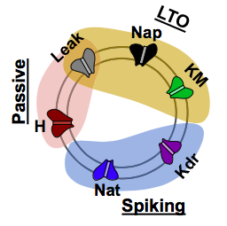**SOLUTION**: The project can be divided into 4 phases, with an analytical + 3 separate modules to reverse engineer the single cell model. The analytical module determines the passive properties using algebraic equations. The spiking module then adds sodium and potassium channels to the cell and tune them to obtain the best fit to the experimental frequency-current (F-I) curve of the cell. The low threshold oscillation (LTO) module and high threshold oscillation (HTO) will add additional channels to accommodate other neuronal signatures.

STEPS TO FOLLOW:

1. Download files from <http://neuromorpho.org/neuron_info.jsp?neuron_name=j130322-01_PC5> .(For this projected the model is already transferred into python form, if you want to learn about how to build the model yourself, please read the supplemental part)
2. Use segregation method to segregate the activate channels into ‘zones of operation’ (Alturki et al., 2016). These will depend on the neuronal signatures that need to be modeled, e.g., passive properties, F-I curve, low-threshold oscillations (LTO) and high threshold oscillations (HTOs). Next, we edit the activation functions to limit the tails and consequently avoid overlap among adjacent modules. The elimination of overlap in these activation functions is termed segregation
3. Match passive properties (purely analytical/algebraic calculations):

We will consider three passive properties: Resting membrane potential Vrest, Input resistance Rin, and Time constant τ.

Using the segregation approach, for the passive part, only H and leak currents are active, and so the other activation function curves will be set to zero

Cell property calculations:

Leak channel reversal [ELeak]:

Value will be the supplied resting membrane potential, **ELeak = Vrest**

Experimental Input Resistance [Rin]:

Based on the segregation hypothesis presented in [Alturki et. Al], and assumption the activations are segregated here, the resting membrane potential will be entirely dictated by the leak reversal. Meaning **Rin = 1/(Area*g_bar leak)** will hold for spiking cells, therefore **g_bar leak = 1/(Area*Rin**)

Experimental time Constant [τ]:

τ is calculated by the resistance times capacitance (R*C). So, **C = tau*(Area* g_bar leak)**

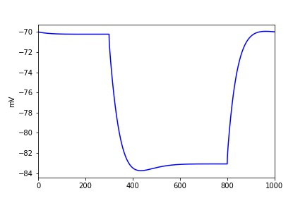Passive property we match is from Alturki et al.,2015, when injected current equals to -0.1, the plot of voltage change is shown below:

The ranges for the parameters are as follows: capacitance 1.0–4.0 lF/cm2, membrane resistance 20–100 KΩ-cm2; axial resistivity Ra 150–200 Ω-cm; resting membrane potential, Vrest from 66 to 75 mV; input resistance (Rin) of 150 ± 10 MΩ and τm of 30 ± 1 ms; sources provided in Kim et al. (2013a)

1. Low-threshold oscillations (LTO): Biological ranges for LTOs in rodent lateral amygdala principal cells is 0.5 to 9 Hz with amplitudes ranging from 2-6 mV (Pape and Driesang, 1998). Two current channels are reported to be involved in generating LTOs: Nap and KM (Pape and Driesang, 1998). So, including the two new channels and vary gbar_Nap and gbar_KM values within the ranges provided.

In this part, we will keep the value for g_bar leak fixed. Then tune the maximal conductances for **KM** and **Nap** to ensure that the LTOs occur around -59mV. You may also need to adjust half activation voltage **(V1/2)** and slope factor **(k)** values for for Nap and KM to ensure that LTOs are in the biological ranges (0.5 - 9 Hz and 2 - 6 mV, at around -59 mV).

1. Spiking module: Keep KM and Nap unchanged, tuning Nat and Kdr to match the F-I curve for the cell.

Experimental Data for type C :0.4 nA for 400 ms elicited 14 spikes when decreasing it to 0.3 nA resulted in 7 spikes. (Faber and Sah, 2003)

1. High threshold oscillation (HTO). These occurs around -40 mV. As performed in experiments, both Nap and Nat should be blocked initially to abolish LTOs and spiking. Current injection will then need to be provided to get the membrane potential close to -40 mV. The main channels related to HTO are Kdr, KM and Ca. Try different sets of gbar_ Kdr, gbar_KM and gbar_Ca values. As with the previous module, you can then adjust half activation voltage (V1/2) and slope factor (k) for Kdr and KM and Ca to fine tune the properties.

*In this Project, we use the detailed signal cell, all components (dendrites and axons) are active.

There are some main channels we will tuned in this project, they are Nap, KM, H, Nat, Kdr.

H channel Control the sag at hyperpolarized level, the pair of Nap and KM are noted as being primarily responsible for spontaneous firing(They are mainly used in LTO in this project), transient sodium Nat and delayed rectifier Kdr currents control spiking.

The other currents in this model, Naf, KA have influence on controlling spiking frequency, but they are not the primary channel, we will keep them fixed. Meanwhile, we select the Type C model and keep the ASP channel fixed.

**TABLES AND FIGURES**

Table 1: Conductance range for different channels

|  |  |  |  |  |  |  |
| --- | --- | --- | --- | --- | --- | --- |
|  | min | | | max | | |
|  | soma | axon | dend | soma | axon | dend |
| H | 5.00E-05 |  | 1.00E-05 | 2.30E-04 |  | 0.0093 |
| Nat | 0.001 | 0.04 | 0.008 | 0.135 | 0.36 | 0.045 |
| Nap | 1.00E-05 |  |  | 0.005 |  |  |
| Kdr | 0.0006 |  | 0.0025 | 0.18 |  | 0.02 |
| Kap | 8.00E-07 |  | 8.00E-07 | 0.048 |  | 0.096 |
| Kad |  |  | 0.04 | 0.008 |  | 0.24 |
| KM | 1E-05 |  | 5.00E-06 | 0.017 |  |  |
| Kca | 1.00E-05 | 3.00E-05 |  | 0.002 |  |  |
| sAHP | 1E-05 |  |  | 0.008 |  | 0.008 |
| Ca | 1.00E-05 |  |  | 0.01 |  | 0.017 |
| Leak | 1.50E-05 |  |  | 1.00E-04 |  | 7.14E-05 |

Supplemental part: How to download detailed cell files and code it in Jupyter notebook

**How to create a morphologically realistic neuron model using Cell Builder**

**Ben Latimer – based on the tutorial at https://www.neuron.yale.edu/neuron/static/docs/cbtut/pt3d/outline.html**

**Step 1 – Download cell from NeuroMorpho.org**

Neuromorpho.org is a database of neuron reconstructions from a plethora of species and brain regions. They are in varying degrees of quality/completeness. A PV Interneuron from the rodent amygdala has been downloaded for you and placed into the DetailedSingleCell folder. Feel free to browse the site for other neurons of interest but use the PV cell to complete this project.

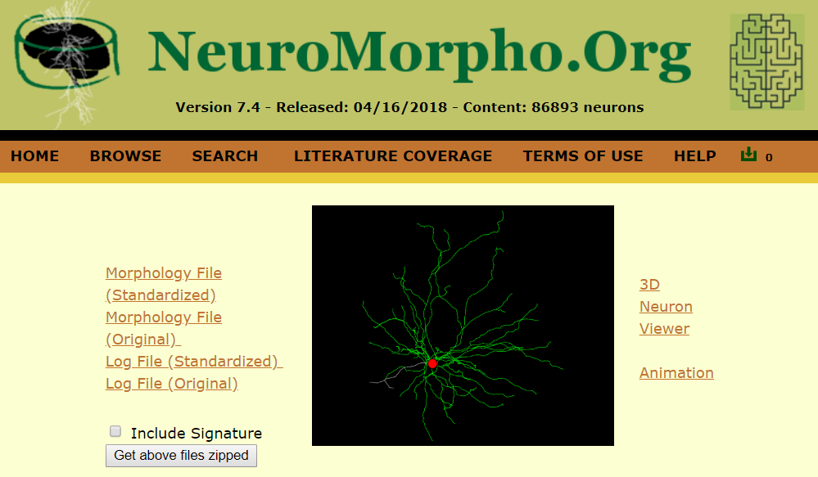

**Step 2 – Import the cell geometry into NEURON**

Open NEURON (note these instructions are for NEURON 7.5) by typing *nrngui* at the command prompt (Mac OS/Linux) or bash shell (Windows). You’ll see the familiar NEURON GUI. Click Tools > Miscellaneous > Import 3D.

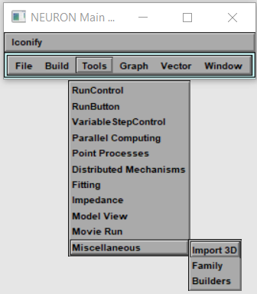

Click the box that says “choose a file” and navigate to the .swc file (PV140912-02.CNG.swc).

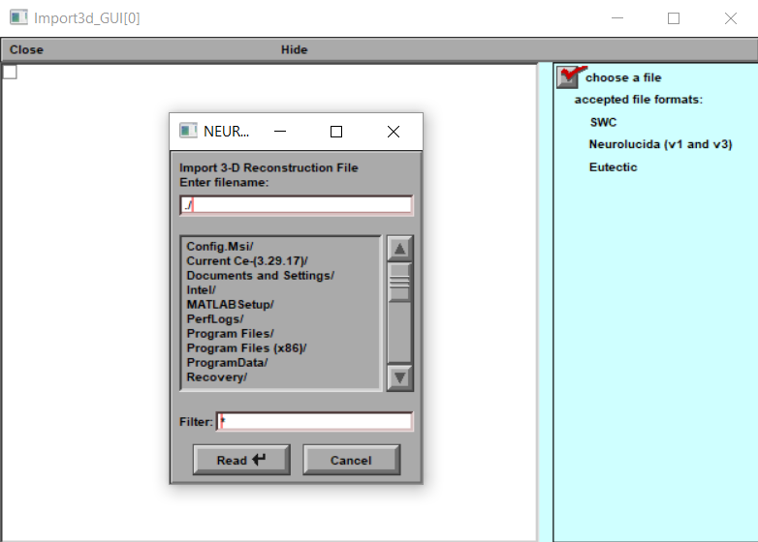

You may see this message:

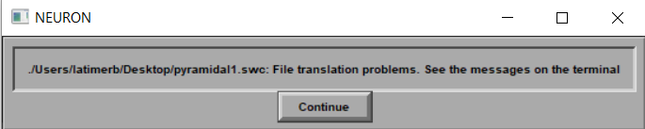

Typically, this is just because there are some comments in the .swc file that couldn’t be interpreted. No need to worry but check out the messages in the terminal anyway.

Now you’ve got a cell! Click Export > CellBuilder

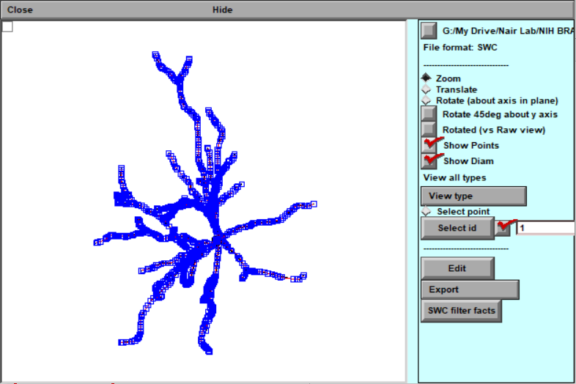

**Step 3 – Make a model of the cell**

Now that we’ve imported our cell from the reconstruction, we’re ready to make a model. Luckily, CellBuilder makes the geometry part easy:

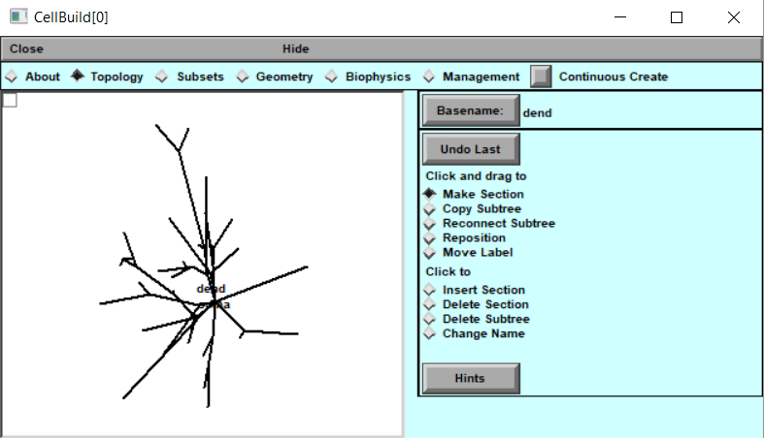

What happened to our beautiful geometry?! It’s still there. Just click “Continuous Create” and go to Graph > Shape Plot in the NEURON main menu.

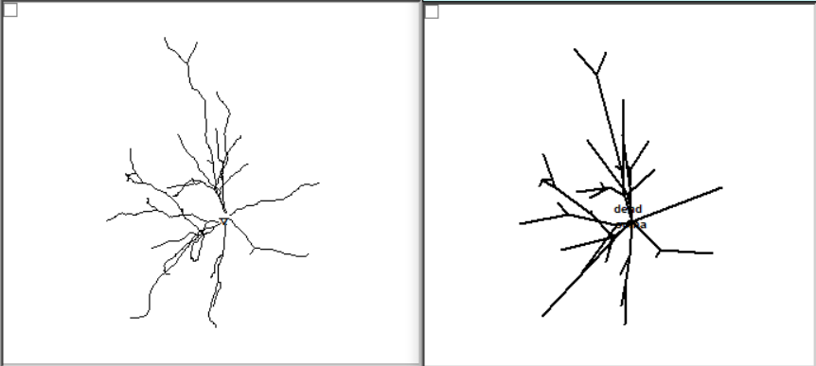

The CellBuilder takes the shortest route between the endpoints of each section when it shows it on the screen but all of the complex geometry is still available.

It’ll be up to us to put in the channels. This is a good time to mention that at any time if you want to save your “session” so you can come back to it later, you have that option. Just click File > Save Session. It’s a best practice to go ahead and save the “bare bones” session (before you embark on the biophysics) so that if you mess up later, you can come back to it.

**Step 4 – Add some biophysics**

At this point, all we have is the skeleton of a cell. We need to specify what channels are involved and the size of the sections. Custom channels such as kdrinter, nainter, and leakinter have been place in the project directory. The regular Hodgkin-Huxley sodium and potassium channels will also be available.

Throughout the process, you’ll use the “Specify Strategy” button to toggle between the list of sections and the values for those sections.

We’re finally ready to add some channels. We’ll add the Na+, K+, and leak channels to the soma and make the dendrites passive.

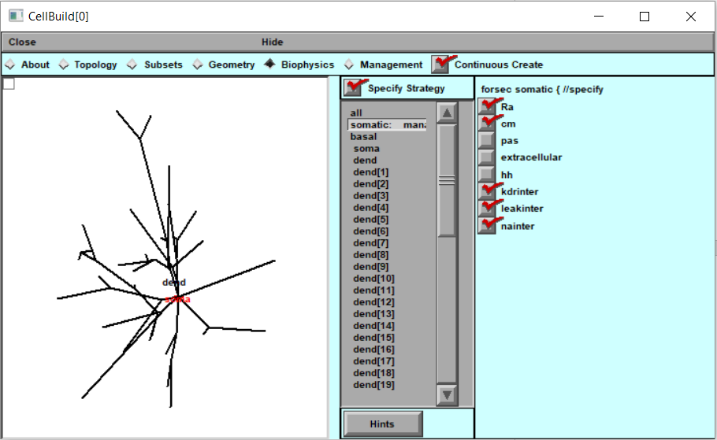

Select Ra, cm, kdrinter, leakinter, and nainter. Then unclick “Specify Strategy”. Now you can go through and specify the various conductances, capacitances, resistances, etc. Add the leak channel to the “basal” category, which is all the dendrite sections.

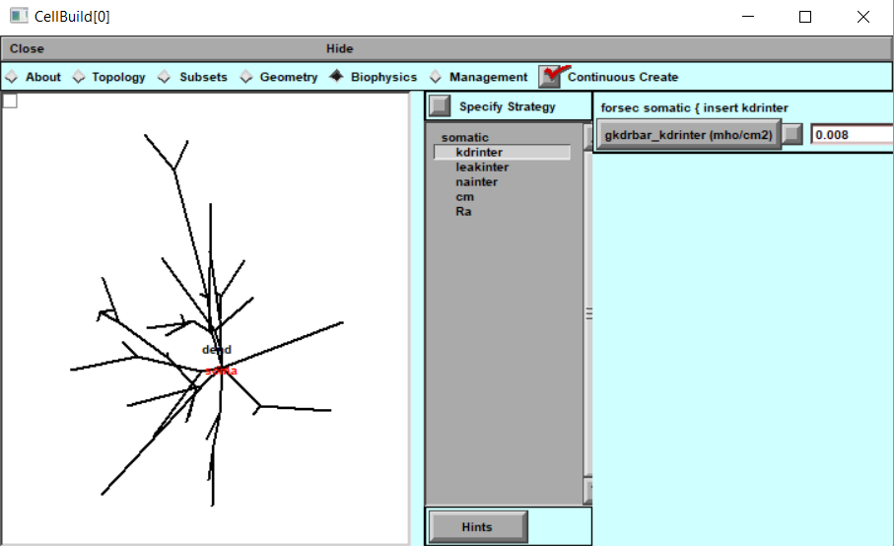

**Step 5 – Put your new cell in a current clamp**

You’ve added all the biophysics you think will be necessary to make your cell behave like you want. Now it’s time to see if it really does. Close NEURON and double-click IClamprig.ses. You’ll see some boxes like this:

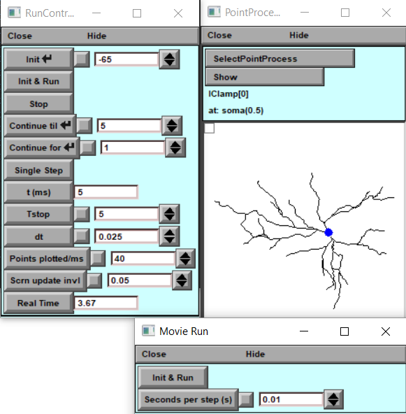

At this point, you will need to “tune” the cell to match experimental data. Many of the parameters are unknown or may be in a range so they can be changed within reason to match the behavior seen in vitro. Start with the values you used for the cell with simple geometry.

**As with project 1a, your goal is to match the passive properties (input resistance, time constant, and resting membrane potential) then match the firing properties (generate an FIR curve).**

To export the cell for use in a template, in CellBuilder click Management > Cell Type. Click Classname and give your cell type a name (i.e. PyramidaltypeA, axoaxoniccell, etc.). Then click “Save hoc code in file”.

**REFERENCES**

Alturki, Adel, Feng Feng, Ajay Nair, Vinay Guntu, and Satish S. Nair. 2016. “Distinct Current Modules Shape Cellular Dynamics in Model Neurons.” *Neuroscience* 334 (October): 309–31.

Pape, H. C., D. Paré, and R. B. Driesang. 1998. “Two Types of Intrinsic Oscillations in Neurons of the Lateral and Basolateral Nuclei of the Amygdala.” *Journal of Neurophysiology* 79 (1): 205–16.

Kim D, Pare D, Nair SS (2013a) Mechanisms contributing to the induction and storage of Pavlovian fear memories in the lateral amygdala. Learn Mem 20:421–430.

Faber ES, Sah P (2003) Ca2+-activated K+ (BK) channel inactivation contributes to spike broadening during repetitive firing in the rat lateral amygdala. J Physiol 552:483–497.